2018 Nevada School Garden Conference
Style A PVC /Rebar Frame LOW TUNNEL
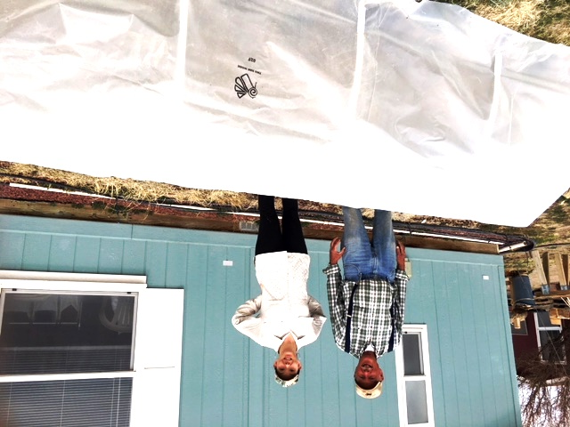
$ 116.34 WITH SEASONAL COVERS

FRAME A MATERIALS
5 PVC Ribs each 78” x ½ “ .22 ft. $ 7.15
1 PVC Ridge Pole 16 ½ ft. x 1” .28 ft. $ 4.62
2 45 degree Elbows .98 $ 1.96
10 2 ft (cut) 3/8” Rebar 1.97 ft. $ 19.70
2 metal cross connectors $ 5.73
12 ½ “ PVC Snap Clamps .58 $ 7.06
4 1 “ PVC Snap Clamps .74 $ 2.93
6 Twist Tail Black Ties .90
2 ½” Steel Rebar 4 FT. 3.82 $ 7.64
Frame Materials $ 57.69
COVERINGS FOR 4 SEASONS
15 FT 30% Knitted Shade Cloth (1.57 FT) $ 23.55
15 FT Agribon 19 (Woven Fabric) (.54 FT) $ 8.10
15 FT Agribon 30 (.60 FT) $ 9.00
18 FT. 6 Mil UV Plastic ( 1.00 ) $ 18.00
4 covers Total $ 58.65
$ 117.55 WITH COVERS COVERSCOVERS
STYLE B WOOD FRAME LOW TUNNEL

FRAME B MATERIALS
2 2” X 6” X 10 FT FIR Lumber $ 8.88 each $ 17.76
1 2” X 6” X 8 FT FIR Lumber 7.11
5 PVC Ribs 75” X ½ “ .22 FT 7.15
1 RIDGE POLE 16 FT X 1 “ .28 FT 4.48
2 90 degree PVC ELBOWS .98 EA. 1.96
1 box # 10 X 3 screws 2.58
24 # 8 X 1 ½ SCREWS .03 ea. .72
10 STRAP ¾ “ EMT 20 / 4.48 2.24
2 strap 1 1/4 “ EMT 5 / 2.18 2.18
2 CROSS-CONNECTORS 5.73
12 PVC ½ “ SNAP CLAMPS .58 EA 7.06
4 PVC 1 “ SNAP CLAMPS .74 2.93
FRAME MATERIALS COST ___ $ 61.90________________

COVERINGS FOR 4 SEASONS
15 FT 30% Knitted Shade Cloth (1.57 FT) $ 23.55
15 FT Agribon 19 (Woven Fabric) (.54 FT) $ 8.10
15 FT Agribon 30 (.60 FT) $ 9.00
15 FT. 6 Mil UV Plastic ( 1.00 ) $ 15.00
4 covers Total $ 55.65

